Rachel Herman
S1C-Spring 2019-EE Capstone
Final Paper
3 May 2019
Dual Power Supply: Twice the Fun
Spring semester 2018 started just like any other. Everyone is getting back in the swing of things after a long break over the holidays. Some are anxious to see what this round of classes will bring them, while others are just looking forward to the warm summer months after their May finals. For the folks in Ivy Tech Fort Wayne’s EECT 211 though, this semester would be far from ordinary. This course, taught by the famed intellect Professor Andy Bell, held key information regarding circuitry, including, but not limited to, resistors, LED, diodes, capacitors, potentiometers, and transformers. After introduction to the course and a few simple labs to get the ball rolling, the big project for the semester was introduced: design and build a 9-volt dual power supply. After asking the right questions to Professor Bell, and some research online, it was determined that a dual power supply is beneficial to the user because it is a budget-friendly solution to boost power supply, as well as give the user consistent and constant power (“Advantages of a Dual DC Power Supply,” 2010). With its wallet cushioning and power supply advantages, there’s no wonder a dual power supply has many uses.
According to Inman and Fritsky “Devices such as mass spectrometers, Geiger tubes and electron multipliers may utilize an adjustable high-voltage dual output power supply to provide up to 8,000 VDC. These supplies generally produce very low currents and are often programmable using a standard serial interface. Some adjustable supplies included in X-ray equipment can produce up to 50,000 VDC” (“What is a Dual Output Power Supply?” 2019). Clearly the boosting power of a dual power supply is quite significant! Some simpler uses that could be seen in everyday life are in PC power supplies, where a logic might need a specific voltage, and the hard drive a different voltage. Other common uses are in audio equipment and applications. Some audio equipment that often utilize a dual power supply would include audio buffers, mixers, headphone amplifiers, microphone amplifiers and VU meters (“+/-12V Dual Power Supply - Electronics-Lab,”2015). While in this particular example with audio equipment, most examples found were 12v dual power supplies, the project assignment for EECT 211 was a 9v dual power supply. The methods used are similar; parts used will just be adjusted.
Now that the common uses for a dual power supply are clear, exploring the advantages of a dual power supply versus a single power supply would naturally be next in line. When looking at the output potential from a dual power supply versus a single source power supply, one will get more bang for their buck seeing as “dual DC power supply is cheaper than running on a single power supply.” (“Advantages of a Dual DC Power Supply,” 2010). Naturally, a dual power supply is going to generate twice the power of a single source power source, while also giving the ability to uniquely transform each supply of power. Reliability is another plus. Depending on the design of the dual supply there is potential there for protection against failure if one of the supplies were to stop working or fail. If one is already in possession of a direct current source, with a little bit of know-how, and the right tools and supplies, creating dual supplies from a single supply can be a fairly easy task. Another big advantage of a dual power supply is its ability to be customized for two different application needing power. If someone would want to power a cooling fan on a computer, as well as power their CD drive, both can be energized with a dual power supply. Finally, as mentioned above, a unique advantage of a dual power supply is its ability to be budget friendly; easy on the pocket book. The explanation behind this comes from a combination of potentially simple design (although some can get quite complex and expensive), and cheap parts involved in assembly. These parts can be found at electronic component stores, as well as multiple vendors online.
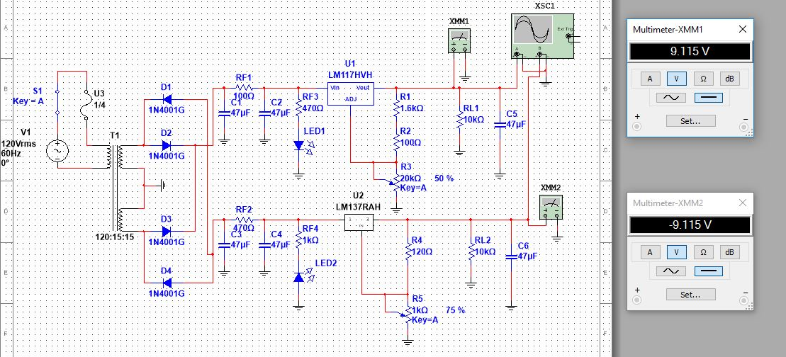
An extremely simple dual power supply can be created by starting with a power source, like a battery, and connecting two in series resistors that are then connected in parallel with two capacitors. Now the values of the capacitors and resistors will be dependent on what the initial input voltage is, as well as desired output voltage, in conjecture with the currant draw of the components one wishes to apply the transformed power to. The dual power supply that was assigned as the project in Professor Andy Bell’s EECT 211 class had a requirement on
9v Dual Power Supply – created by Rachel Herman and Jason Block
components that must be used. These components included: a 3-pronged power cable, for the initial power source of 120v AC, a fuse and fuse holder for protection, a switch to control current, a transformer, an assortment of diodes, two chips, resistors, LED, potentiometers, and capacitors. The class was given the instruction to first design a working dual power supply using MultiSim. In total, on a single dual power supply, four diodes, two LEDs, six capacitors, eight resistors, two potentiometers, two chips, and one transformer was used. In order to obtain these parts, Professor Bell instructed the class to research online at www.elexp.com and put together a bill of material for the parts needed. Included in the bill of material was to be component name, rating, price, part number from website, and quantity. On average, the creation of this specific
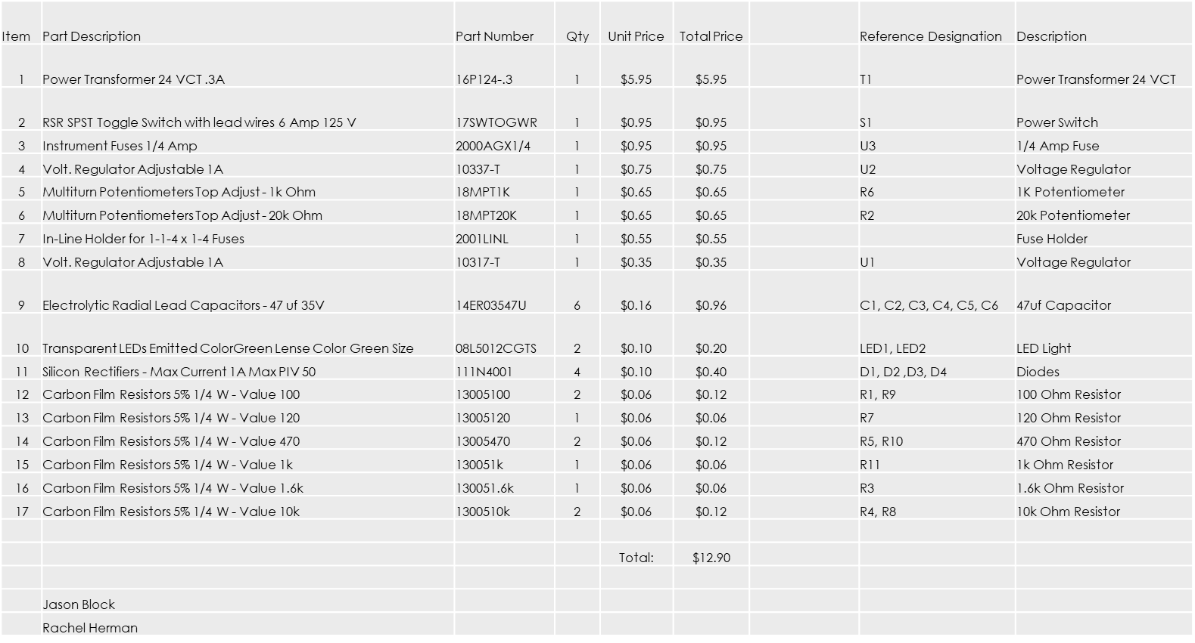
design for a dual power supply cost between $12.00 and $16.00.
Bill of Material – Created by Rachel Herman and Jason Block
Each component used in this build plays a vital role in the power supplies ability to work correctly. Initially, the switch and fuse will act as fail safes. If the operator does not flip the switch, the power supply is void of any power. In conjunction, if the current being drawn is in excess to what the fuse is rated for, it will blow, deenergizing the circuit. After the switch and the fuse comes the power transformer. A power transformer is a common electrical component that uses wound wire and current to produce a magnetic field and transform the power, either up or down in voltage. After the input power is transformed, it is sent through a series of diodes. The manner in which these diodes are arranged is crucial to the dual power supply. The setup used in this design is called a bridge rectifier. Once through the bridge rectifier, there will be two legs of
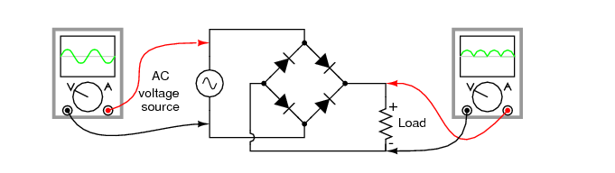Image of bridge rectifier from https://www.allaboutcircuits.com/textbook/semiconductors/chpt-3/rectifier-circuits/
current, one will need to be adjusted to around 9 v and the other to -9 v. In order to complete this alteration, the currant will travel through a capacitor, which is a component that stores power, connected in series with a resistor, which will reduce the flow of the current, then another resistor and LED connected in parallel with the first capacitor. From there, the current will travel through a voltage regulator, connected in parallel after the voltage regulator is another resistor followed by a potentiometer, which in basic terms is an adjustable resistor. Finally, the current will run through another resistor and capacitor, to which after the voltage measurement can be taken. In the dual power supply assigned in this course, the goal was +/- 9v.
Once one has designed the circuit, tested said design in MulitSim, ordered the components for the circuit, and tested each component to ensure all values are correct, it’s time to assemble the parts. Professor Bell provided each bench with a circuit board with a grid pattern of pre-punched holes for the legs of the components to be placed in. That’s going a bit too far ahead of the plan just yet, though. First one needs to test the theory of Multisim design in a real-world environment. In order to do this, the components will need to be arranged exactly per the design in the Multisim on a breadboard. This gives the user the ability to test the circuit and make any adjustments that may be necessary before soldering everything together on the
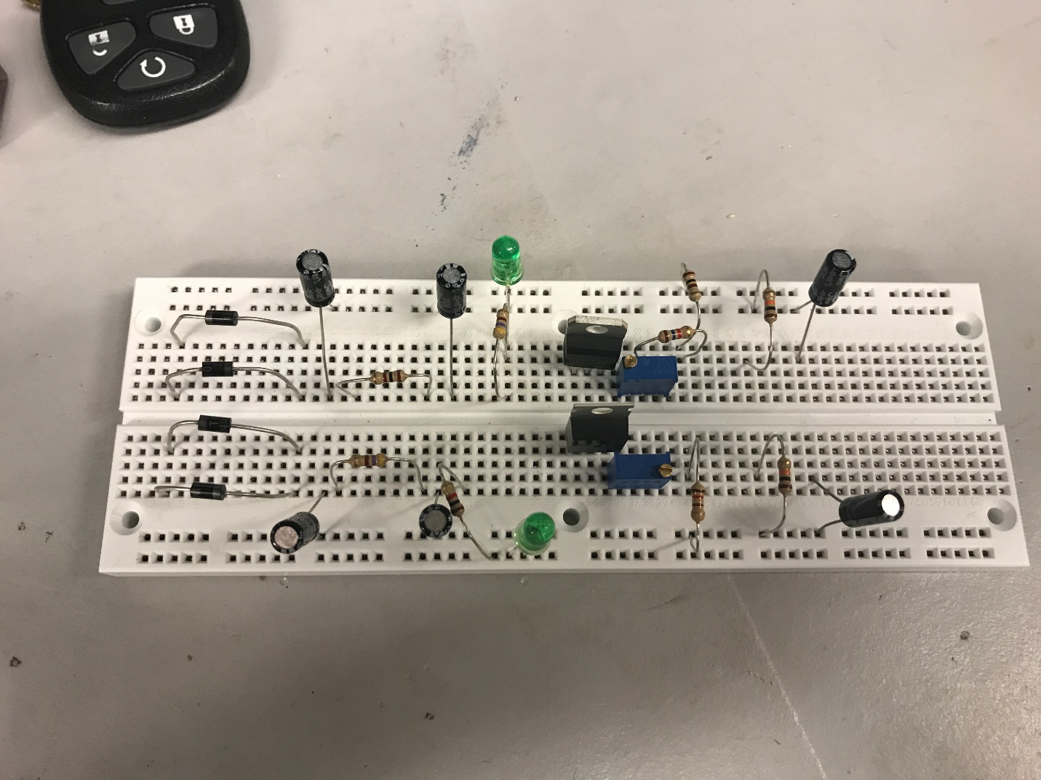Breadboard with circuit layout – By Rachel Herman and Jason Block
provided circuit board. A crucial adjustment that will have to be made is to the potentiometers. Each potentiometer has an adjustment knob at the top that gives the user the ability to adjust the resistance up or down, which in turn makes it so the output voltage can be fine-tuned. This step of setting up the circuit and testing can get quite tedious. If the initial design with the Multisim had any flaws, or the values of the components were miscalculated, it will all show itself here. Once the circuit is in good working order, it’s time to transfer the pieces to the circuit board and begin to solder.
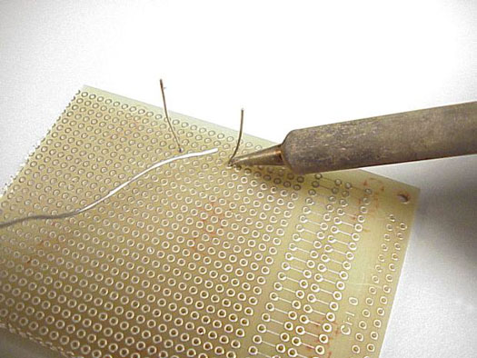
Soldering is not something that was taught to the students in this class prior to it being required for this project. Before one gets started, they will need to ensure that they have all the tools necessary as well as the proper protection. Personal protective equipment that is required are safety glasses to protect one’s eyes, and the common sense to not putting one’s fingers in their mouth after touching lead solder. Tools that one will need in order to solder effectively are a soldering iron, rosin-core solder, and in some cases flux. According to dummies.com how to solder comes down to these basic steps: “The best technique for soldering is simple, so repeat
Solder iron, component legs, and solder on circuit board – https://www.dummies.com/programming/electronics/what-is-soldering-and-how-do-you-use-solder-tools/
this mantra: Heat the metal, not the solder. For example, you heat the metal of a component pin and the metal of a circuit board pad simultaneously, and then you touch the tip of the rosin-core solder to the pad or the pin, but not to the iron. If you have sufficiently heated the two metals (the pad and the pin), they will heat the solder, which then flows quickly to both the pad and the component pin.” (“What Is Soldering and How Do You Use Solder Tools”). Dummies.com also goes into the importance of a good solder versus a bad solder. A bad solder joint can lead to many problems with the circuit, and in the long run could be hard to diagnose.
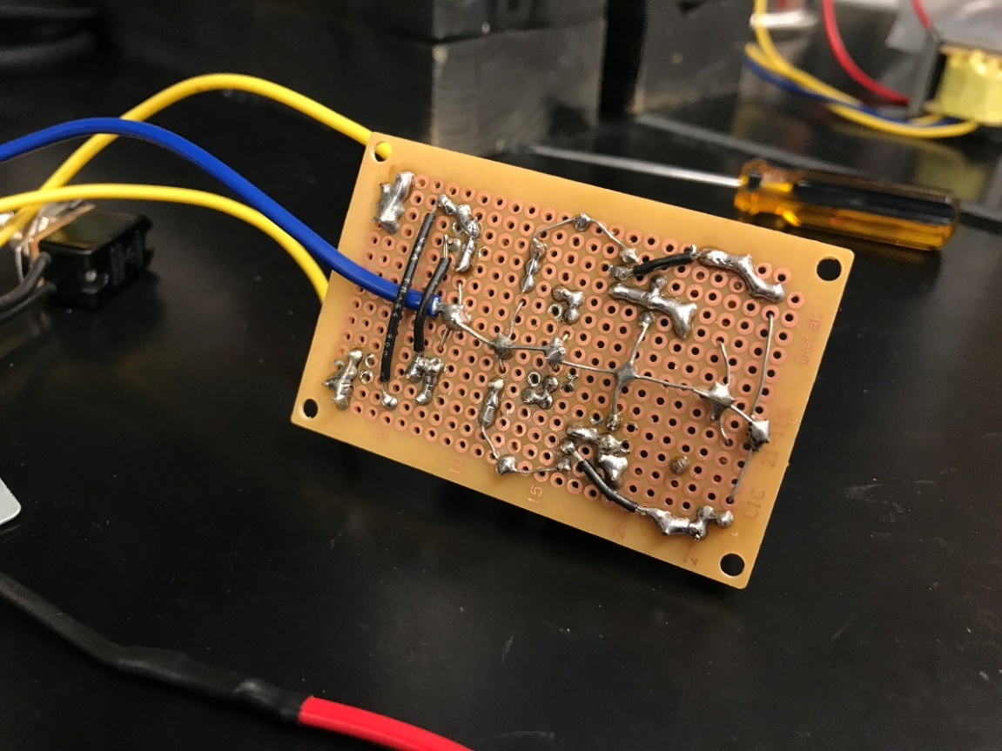
Once soldering is mastered, it’s time to assemble all components and determine the best layout on the circuit board. Once all the pieces are in place, it’s time to solder. It is best for beginners to solder one piece at a time and test for continuity after each solder to ensure that the connection made was a good one. One by one the circuit will start to come together, and before long it will be time to test!
Back of 9v dual power supply after soldering – By Rachel Herman and Jason Block
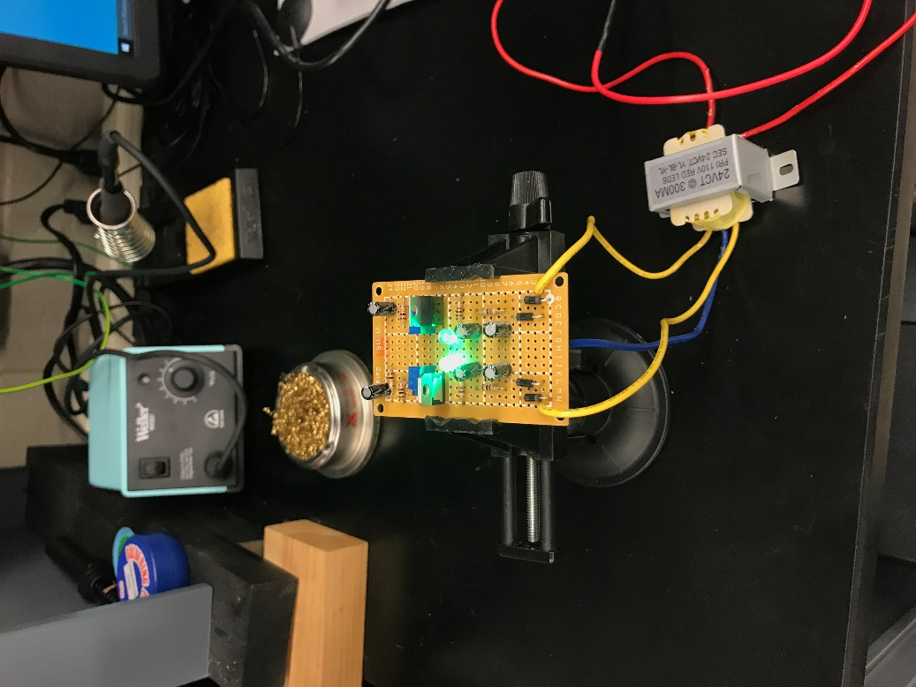
The testing of this dual power supply can be done with a digital multi-meter. The digital multi-meter will need to have the probes placed at the end of one leg of the circuit and on the common ground. Test one leg and then the other. For this assignment in EECT 211 it was required to have one leg with +9v and one leg with -9v. After confirmation has been made that the power supply produces the correct voltage the dual power supply is complete!
It works! – By Rachel Herman and Jason Block
In conclusion, a dual power supply is beneficial to the user because it is a budget-friendly solution to boost power supply, as well as give the user consistent and constant power. With a little bit of research and some additional know how, one can build one of these fairly cheap, and with not too much effort put into it. This design can be customized for multiple applications, as well as be created to different output voltages. The components involved are not expensive and are typically easy to install. Soldering is a skill that may need to be learned if one does not have any prior experience with it, but eventually it will all start coming together. Dual power supplies are and will continue to be a very useful part of modern technology.

Work Cited
“+/-12V Dual Power Supply - Electronics-Lab.” Electronics, www.electronics-lab.com/project/12v-dual-power-supply/.
“Advantages of a Dual DC Power Supply.” Do It Yourself, DoItYourself.com, 23 Feb. 2010, www.doityourself.com/stry/8-advantages-of-a-dual-dc-power-supply.
Inman, Kurt, and Lauren Fritsky. “What Is a Dual Output Power Supply?” WiseGEEK, Conjecture Corporation, 8 Apr. 2019, www.wisegeek.com/what-is-a-dual-output-power-supply.htm.
“LATEST.” All About Circuits, www.allaboutcircuits.com/textbook/semiconductors/chpt-3/rectifier-circuits/.
“What Is Soldering and How Do You Use Solder Tools?” Dummies, www.dummies.com/programming/electronics/what-is-soldering-and-how-do-you-use-solder-tools/.

